# The changing habitat of Solanum Tuberosum

## Introduction

*Solanum tuberosum* is a much-cultivated plant and has fed families for centuries all over the world (Hawkes, 1992). Originating from present USA, the plant has been domesticated and dispersed by human hand. As seen in figure 1, the *S. tuberosum* is established on every continent short for Antarctica. The root of the *S.* *tuberosum*, cultivated for the potatoes it produces, are nutritious as they are high in protein and vitamin B6 (www.voedingscentrum.nl).

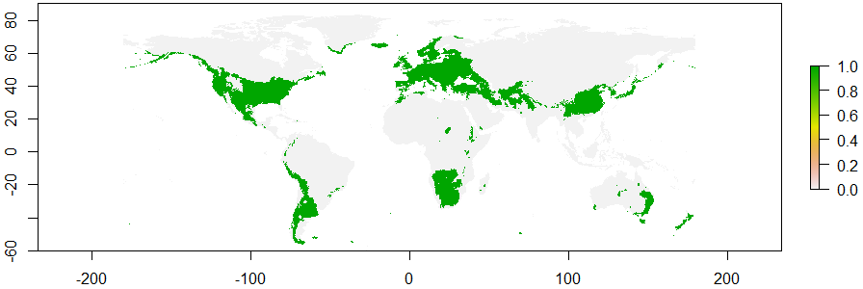

1. Occurence Solanum tuberosum present.

For this report we will look at the change in habitat suitability when present and future climate conditions are compared. These two Species Distribution Models (SDMs) will represent change in habitat suitability of *S. tuberosum* on Earth, determined by abiotic factors.

## Methods

To create a suitable SDM for the *S. tuberosum*, the application MaxEnt is used.

The database from gbif.org is connected to the previously selected climatic variables in R. Present occurrence is established, and from the comparison with the change in climatic variables over time the future distribution of the species is determined. For this, linear and quadratic features are selected in MaxEnt, as they are best suitable for a SDM.

The climatic variables are all based on temperature or moisture. For this report on the *Solanum tuberosum*, the four variables that are selected are bio2 (Mean Diurnal Range), bio6 (Min Temperature of Coldest Month), bio13 (Precipitation of Wettest Month) and bio14 (Precipitation in Driest Month).

As seen in figure 2, the variable that appears to be of most influence is bio6. The other climatic variable that is of some influence would be bio13. However, bio2 seems not to be of much influence and bio14 does not contribute at all to change in habitat of *S. tuberosum*. Due to time limitations (2.5 hours to run everything in MaxEnt added to the incredibly long time to run R) and a very large database (21.000 rows), other climatic variables have not been proposed or tested.

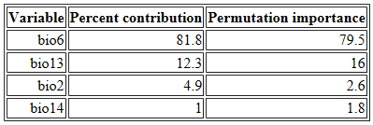

2. Analysis of variable contribution

## Model Output

The results of the SDMs are shown in figure 3 and 4. Despite a large importance of minimal temperature in oldest month, almost no difference can be seen between present and 2050. Largest differences can be found in Australia and South America.

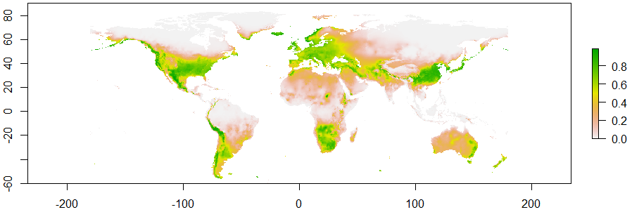

3. Suitable habitat Solanum tuberosum when looking at climate variables present.

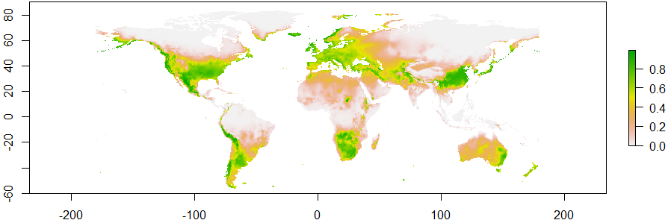

4. Suitable habitat Solanum tuberosum when looking at climate variables in 2050.

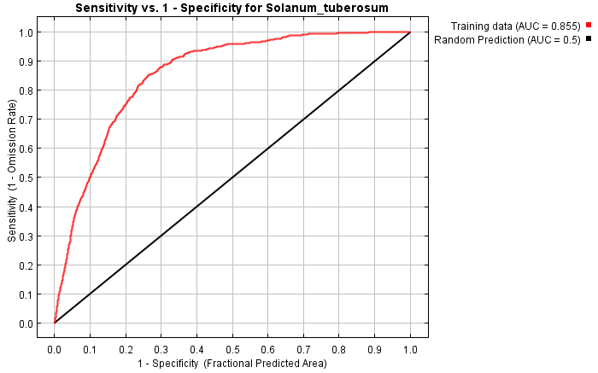The threshold of ‘Maximum training sensitivity plus specificity’ had a value of 0.466.

Also, the AUC value can be considered good as well (figure 5), as it is 0.855. This consolidates that the model is accurate in predicting presence sites of the population, validating the SDM.

Testing against a null-model would even further solidify our model.

5. AUC value

## Response to future scenario

In figure 6 the differences between present and future habitat suitability are shown for *S. tuberosum*. Just as seen in the present and future SDM (figure 3 and 4), the effect of climatic variables is small.

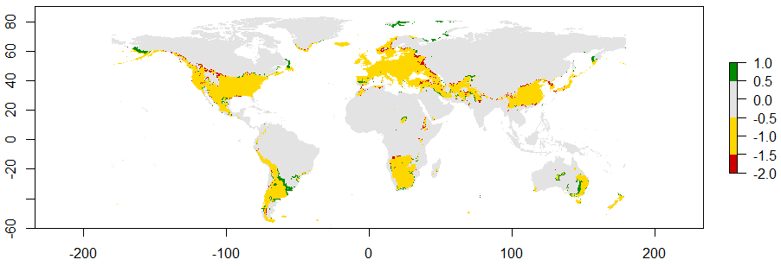

6. Differences between present and future in habitat suitability at occurrence scale for Solanum tuberosum.

## Biological interpretation

From figures 3, 4 and 6 there can be concluded that the effect of climatic change on *S. tuberosum* is almost insignificant. Between present and future, the selected variables do not seem to affect habitat distribution to a large extend. This would mean that this crop is able to grow in future years without difficulties from climatic influences on the same locations it survives now. When looked at the climatic variables considered, the small location changes in habitat can be explained. The minimum temperature of the coldest month (bio6) is of importance to *S. tuberosum*, as it is best adapted to cool temperature zones (Hawkes, 1992). Also, precipitation of wettest month (bio13) has some influence for a suitable habitat for *S. tuberosum*. This would be because of too much precipitation would spoil the potato crops and make in impossible to cultivate. About the other climatic variables (bio2: mean diurnal range and bio 14: precipitation of driest month) no conclusions can be drawn, as their relative importance is too low to have any influence on the outcome.

A lot of different factors are not taken into account by this SDM. Other variables of climatic change, and even biotic factors or accessibility could still affect distribution of *S. tuberosum* considerably. These could influence the species differently, changing the outcomes of the distribution model. Moreover, when alternative temperature or moisture variables would be considered (and tested with running MaxEnt again), chances are that there are some variables or bigger influence. This would result in a model indicating more change in habitat.

Additionaly, *S. tuberosum* is exclusively used as crop and does not grow anymore in free nature. The species is intensively bred and constantly ‘improved’ to fit the environment on the place it is needed. This would mean that the species does not exhibit natural selection, and therefore the SDM is less representable. On the other hand, the SDM could be of help to let the breeders know in what way to select *Solanum tuberosum*.

## References

Aardappelen (2017, december 10). Retrieved from http://www.voedingscentrum.nl/encyclopedie/aardappelen.aspx

Hawkes, J. G. (1992). History of the potato. *The potato crop: The scientific basis for improvement*, 1-12.

Hawkes, J. G. (1992). Biosystematics of the potato. *The potato crop: The scientific basis for improvement*, 13-64.